Q.1.
1. Basis Set up
- Router 1
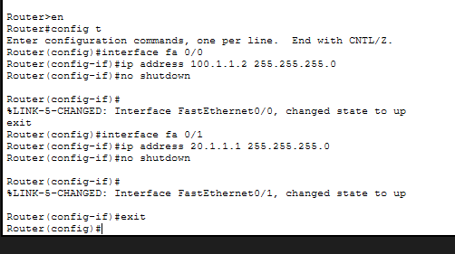
- Router 2
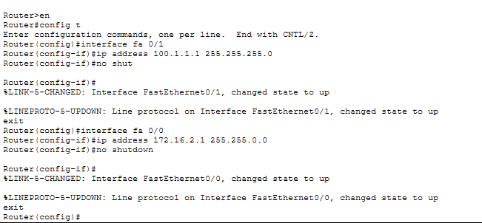

- Router 3
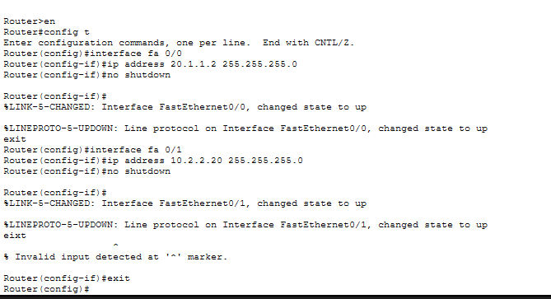
2. Setting up RIP
- Router 1

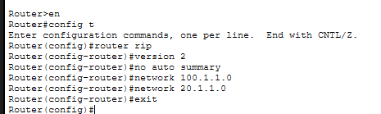

- Router 2

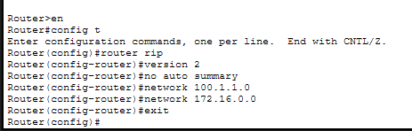

- Router 3
